Task 5
- Download tomcat and deploy the artifact.
Step 1: Download Tomcat:
- Go to the official Apache Tomcat download page: Tomcat Downloads.
- You can download the latest version of Tomcat, typically a .tar.gz file. For example apache-tomcat-9.0.98.tar.gz
Step 2: Untar the apache-tomcat-9.0.98.tar.gz in tomcat directory using command tar –xvf <file name>
Step 3: cp the .war file in the below path
cp Amazon/Amazon-Web/target/Amazon.war ~/tomcat/apache-tomcat-9.0.98/webapps/
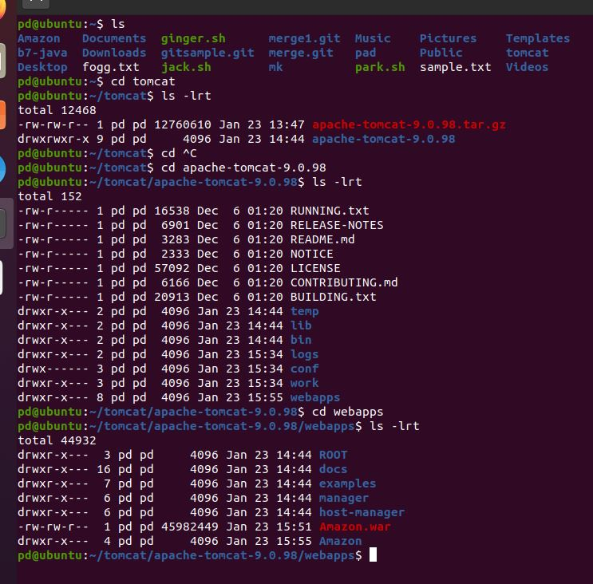
Note: In this webapps directory, where we can deploy our artifact.
We need to copy any artifact only in the webapps dir and it contains applications like .WAR files
- Install the tomcat, deploy and access in the windows
Step 1:
• Download Tomcat:
- Visit the official Tomcat download page: Tomcat Downloads.
- Download the Windows zip version of Tomcat (e.g., apache-tomcat-9.x.x.zip).
• Extract the ZIP file:
- Once downloaded, extract the .zip file to a folder of your choice, such as C:\Program Files\Apache Software Foundation

Step 2: Start Tomcat
- Navigate to the bin directory:
C:\Program Files\Apache Software Foundation\Tomcat 9.0\bin
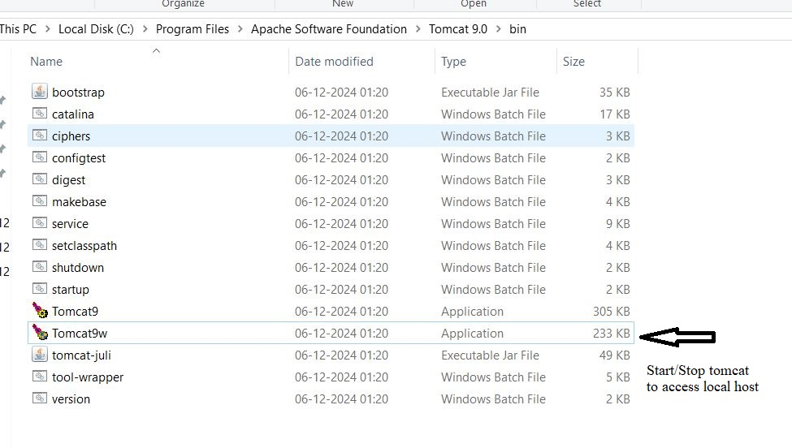

Step 3:
Access your localhost in browser by giving the hostname i.e.., http://localhost:8080/
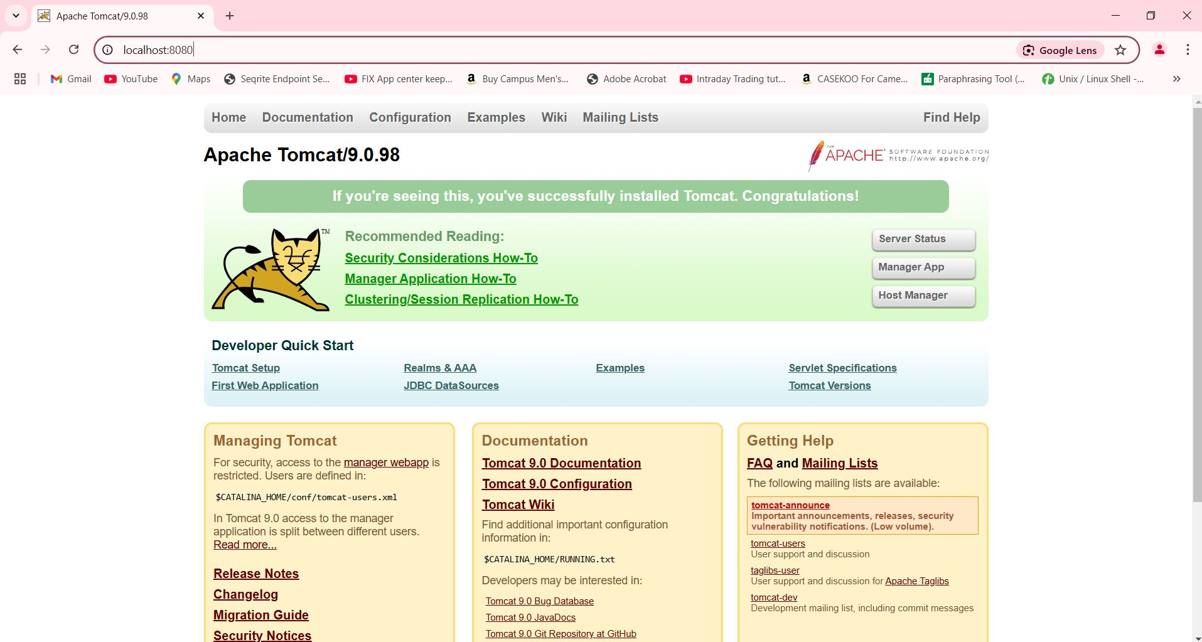
In continuation we can open apache manager page, which we can deploy java application I,e.., http://localhost:8080/manager/html
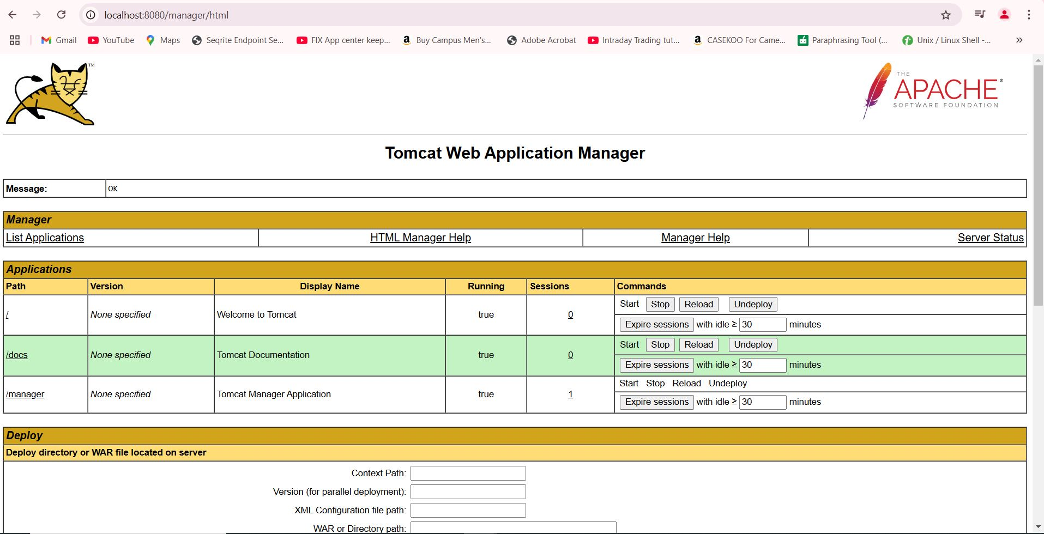

Step 4: If we want to change user name and password have to go to the below mentioned path
C:\Program Files\Apache Software Foundation\Tomcat 9.0\conf
And open with notepad to check username and password and change if required
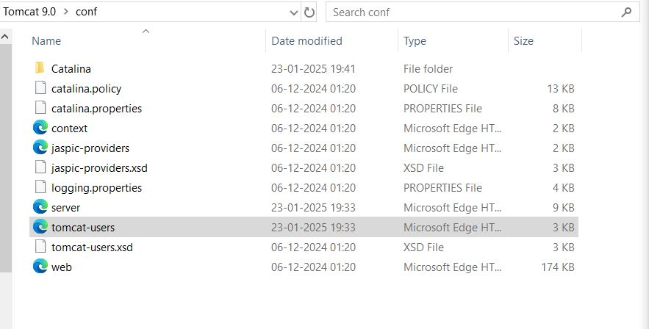
.3. Difference between the war and jar file
Feature | JAR (Java Archive) | WAR (Web Application Archive)
Purpose | Used for Java applications and libraries | Used for web applications (for servers like Tomcat)
Main Content | Java classes, libraries, resources | Web app resources, Java servlets, JSP, HTML, etc.
Deployment | Run directly as a Java application | Deployed to a web server (e.g., Tomcat)
Typical Usage | Libraries, desktop applications, utilities | Web applications (JSP, Servlets)
Directory Structure | JAR contains just the application code and resources | WAR contains WEB-INF/ directory with configurations

